**Group 8**

**Rabia Mehmmod 19l-1167**

**Saba Zahra 19l-2224**

**Iman Jawad 19l-2737**

**Task 4**

Frameworks used for React Storefront are

* Enzyme
* Jest.

**Jest**

Jest is a JavaScript testing framework designed to ensure correctness of any JavaScript codebase. It allows you to write tests with an approachable, familiar easy-to-understand API that gives you results within no time.

**Screenshot**

API call is made and tested using jest

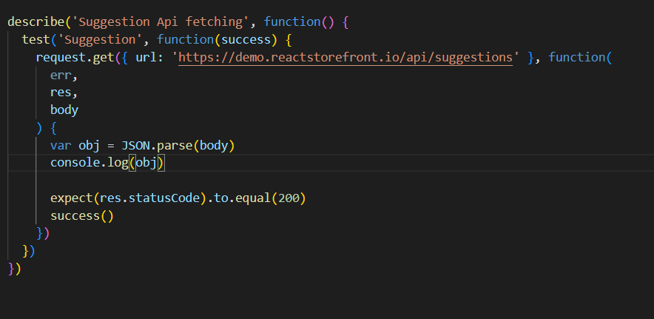

**Enzyme**

Enzyme is a JavaScript Testing utility for React that helps to test React Components' output. You can traverse and simulate at runtime. Enzyme's API is meant to be intuitive and flexible by mimicking jQuery's API for DOM manipulation and traversal.

**Screenshot:**

.

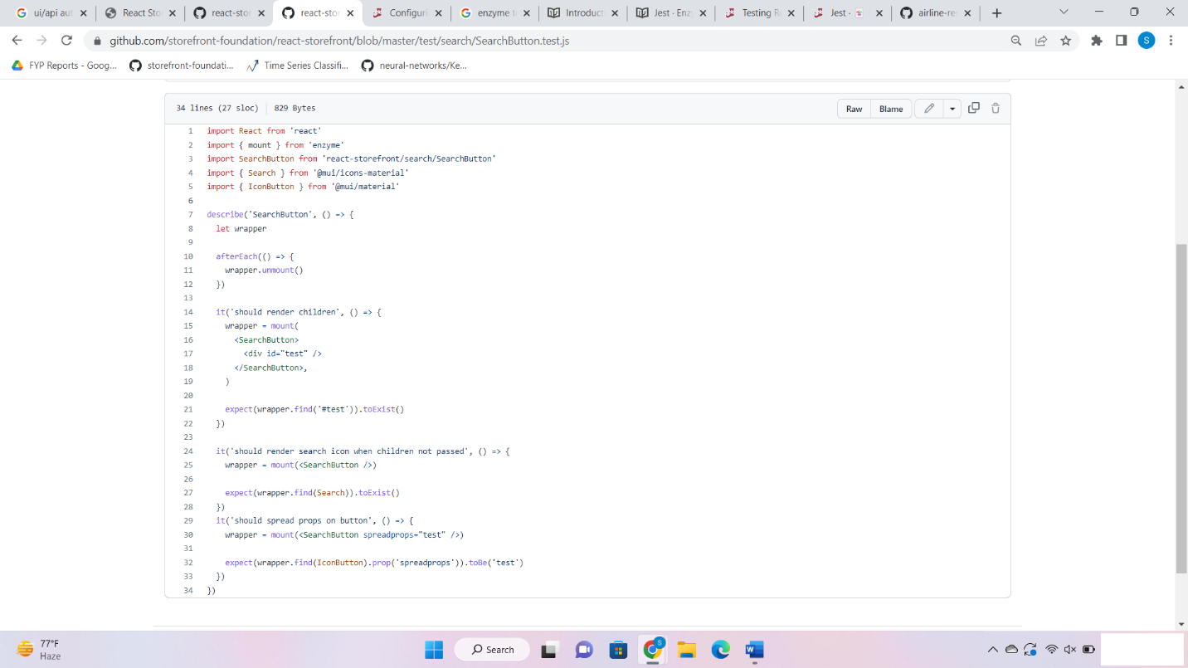

In this example code from the public repository of react-store-front, both jest and enzyme has been used to test UI.